June newsletter: Last half of the Champagne and Summer Leagues, good luck to all involved.

Edinburgh Marathon
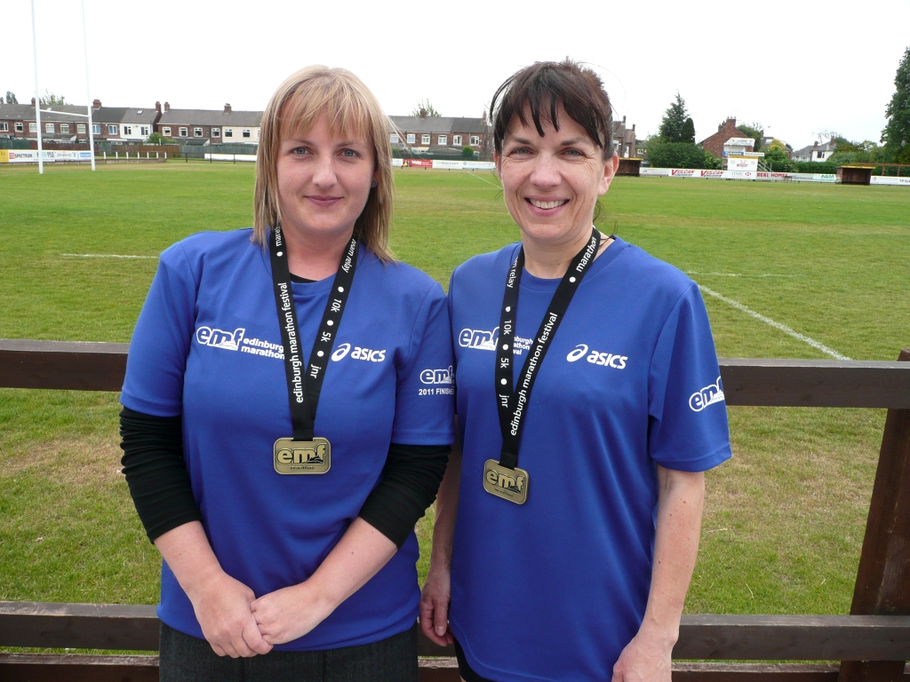

Katy and Debbie

We have some great writes ups this month from an American 5K, a number of 10K races to the Edinburgh Marathon. Enjoy.

Training Officers : Running Tips

From your training officers, in order of importance:

- Enjoy your running:
Hopefully with such a lot of friendly, supportive and positive runners in the club it’s not too hard to get out and run regularly.

- Run efficiently to make it easier:
In the last newsletter there was an article about over striding. Take note and learn to land on the ball of your foot, not your heel, which causes you to brake at every step. Take note of your posture, remember your legs do the work and hips upwards should be upright and your shoulders relaxed with a gentle arm movement. Learn to breathe down into your stomach.

- Avoid injury
- By learning to run well (no. 2);
- By cross training, in particular doing exercises to strengthen your core muscles
- By stretching. Work out what are your tight bits and stretch them regularly
- By looking after yourself: sleep well, eat well, stay healthy. If you are tired, under the weather your body is too and you are more prone to injury at this point so learn when it is prudent to go easy.

- Increase your weekly mileage.
It’s really easy to get hooked on how well you are doing because you have run further than ever before at one go but your weekly mileage is more important and all our marathon runners can tell you just how true this is. You might feel really pleased that you have run twice in a week doing a 4M and a 7M but running 5M, three times a week is better. The weekly mileage is your foundation and building this up steadily will strengthen joints and muscles without risking injury.

- Run further

It is very positive to run further than before and as long as you do this gradually and alongside building up your weekly mileage you will ‘take it in your stride’.
Formula:
Long run = daily average mileage x 3.

Weekly | Daily | Long Run
14M | 2M | 6M
21M | 3M | 9M
28M | 4M | 12M
35M | 5M | 15M
42M | 6M | 18M
49M | 7M | 21M

- Speed train
Its fun and you get faster. Don’t miss the sessions.

Happy running,
Amanda & Jo

WEST HULL LADIES RRC
COMMITTEE MEETING MINUTES 06.06.2011
Attendance – Rebecca King, Amanda Dean, Verity Pick
Apologies – Annette Pearson, Louise Ede, Victoria Voase, Jo Townsend
1. Membership – Thank you to Victoria for emailing the updated membership list. Annette is processing the information and sending the "removing from distribution list" e-mail to lapsed members.
2. Letter to Hull Sports – Becca reported she has not had a response to the letter she sent regarding club payment.
3. Officers Reports – Verity, racing officer, reported that the racing website is up to date with all the racing entry forms she has received. Amanda, training officer, reported that there is a very buoyant atmosphere in the club and that races are going very well for a lot of members.
4. AOB – None
June Muscle of the Month: Rotatores (the Rotators)

Where is it? The rotators are situated in the back and link each vertebra to the next, all the way up the spine from the sacrum in the pelvis, up to the base of the neck.

What is it and what does it do? The rotators are part of a group of muscles called the transversospinalis muscles. This literally means that they transverse the spinous processes (or nobbly bits) on our spine, linking them together. They rotate the spine to the opposite side. This means that if we want to rotate our trunk to the right, it is the rotators on the left that will contract to perform this function.
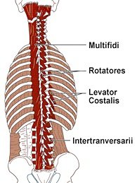

How does it get injured? These are very deep muscles so don’t get injured as easily or as often as more superficial ones, but when they do get injured it can be more difficult for them to heal and be treated. Generally, postural imbalances or trauma such as road traffic accidents or falls cause this muscle to be injured. Poor posture when lifting heavy objects also leads to tears and injury to this muscle.

How can these be treated? Deep tissue massage is good for treating this muscle. Due to how it links the vertebrae together, it can cause vertebral misalignment, so manipulation of the bones can also help to restore rotatores to its proper position and balance.

How do I stretch it? Very simply, to stretch the rotators on the left hand side, you will need to turn your trunk to the left hand side, and vice versa.

How do I strengthen it? Maintaining a good posture when sitting, standing and running.

Which muscle groups are related to it? The other transversospinalis muscles such multifidis and semispinalis, but also the paravertebrals, situated close by in the back.

Did you know....? A great deal of running injuries are caused by wearing old or worn-our running shoes. How often you need to change your running shoes depends on a number of factors. As a rule of thumb, however, most runners need to change their shoes every 300-500 miles – so remember to keep a running diary!

About me
I am an Advanced Remedial Massage and Manipulative therapist based in Cottingham, Hull and Beverley. I treat a variety of sports people in my clinics and I am always delighted to treat members of the West Hull Ladies running club so if you would like to book an appointment or if have any questions, you can email me at kirstieannskelton@hotmail.com, call 07789 914597 or visit my website www.kirstieannskelton.com for further details.
I will be on maternity leave for a couple of months, probably starting at the end of May. I will be writing to all my patients to advise them of my return date as soon as possible.

Race Write-Ups or Write-Offs:

Edinburgh Marathon

Katy: Oh my goodness, what a day!! I arrived in Edinburgh on the Saturday, and my knee was pulling (it hadn’t caused me a problem for a while so I convinced myself it was all in my head!) After another meal of pasta (god I can’t wait to have a non-pasta meal), I had an early night listening to the rain outside.
I woke up at 5.30am the following morning, and it was still raining outside. I went for breakfast prepared with my sachet of porridge, and I saw quite a few disgruntled runners who were told that porridge was not on the breakfast menu.
As I made my way to the start, it rained, it was sunny, it was gale force winds, a complete mix, but I had given myself a stern talking to before leaving the hotel to remain positive! As we were moved into our starting pens, I shuffled in between 2 ladies, Ali from Aberdeen and Sharon from Manchester. It was the first marathon for all of us, and we all looked equally nervous but chatted as we were moved towards the start.
We crossed the start line to a team of bagpipe players, it was great. We were chatting away and the first 10 miles passed and we were still chatting! Ali stopped to walk as her knee was pulling, and Sharon and I continued to mile 13 (I had never ran this far before without stopping). We stopped for an energy gel and then continued along the coast to mile 17 where Sharon said she needed to walk for a bit. Now, if you ask anyone at the club, I NEVER pass up an opportunity to walk however my reply on this occasion was 'I really need to carry on, I feel fine and I want to finish in under 5 hours????!!! What had happened to me???!!
I carried on up the coast which was not hilly but steady inclines and I stopped for a quick wee break at mile 20 as the portaloos had no queue. From there, the wind must have been close to gale force because it was blowing people across the road. From mile 24 a lot of people were walking but I carried on and got a second wind and finished in 4:53:06 which I cried about when I crossed the finish line!
The support around the course was absolutely amazing, and there were people along every part of the windy / rainy / sunny route. I have pre-registered for next year already, it was such an achievement and I would recommend it to anyone.

Debbie: This was a trip down memory lane for me. My four youngest were born here, looking at the beautiful back-drop of Arthurs Seat reminded me of long Sunday walks pushing a double buggy.
The DJ announced that there were 20,000 runners and that this was a fast course and really good for a pb! So, no pressure. The first person I bumped into was my daughter Lucy's ex boyfriend Edward, he happened to be in the same pen as me so we spent a while nattering about pace, mp3 players (which were banned) and times. I wondered how Katy was feeling and hoped that she would have a good run.
The weather was mixed, it was cold and wet at the start, then warm and sunny and continued to change all day,the wind really got up for the last stretch as well as a helping of hailstones!
The race was well organised and started promptly. I had a very good starting position and soon got into my pace after we crossed the line. At about mile 3 - 4 we were running along a coastal path, in fact this is a coastal route even the road section is leafy and quite pleasant. The mile markers were hard to spot, however the beep beeping of thousands of gps's were a good indicator that another mile was out of the way.
After the half way point we got away from the coastal path and were on a very long stretch of road which was to continue for about 10 miles, albeit with a few deviations. I felt all was going well, I passed Edward at the half way mark and gave him a cheery wave and thought my target time of sub 4hours could be achieved. At mile 16 I had a sharp pain in my stomach which was a bit alarming because it wasn't stitch or needing a toilet stop. I held it for a while and really hoped it would go away, my initial reaction was to bend over to stop the pulling, I knew this would be a bad idea so I stretched out my torso and hoped for the best, thankfully it passed.
The weather started to deteriorate and the front runners were starting to come back past us, things were getting busy on the stretch of road and I was beginning to dig in. At mile 18 we turned off into a country estate which was very pleasant, the heavens opened and the wind started to get up, but the crowd were fantastic, shouting words of encouragement with cries of 'yous can do it keep goin' which made me smile. I completely missed mile 19 and 20 markers at which point we came out of the estate and were on the homeward stretch.
At mile 21 my legs were beginning to feel it ,my quads were getting sore and I knew I had to dig deep and keep going, I was on the last stretch and it really wasn't far. Then the wind started blowing right at us and if that wasn't enough it started to hail. I could see that my pace was dropping, people around me started to walk in fact everything, despite the wind, went very quiet, the crowds were doing their best to raise our spirits I heard someone shouting 'come on west hull' which I appreciated. I thought I might just get under the 4 hours and kept going.
At mile 25 the wind eased off and the sun started to shine again and there was the clock only 100 meters away but it seemed so much further. I couldn't quite see the time but when I eventually saw 4.00 on the clock I thought come on pick your feet up you might just have done it so you may as well push right to the end you don't have to run next week! In the finishing funnel I checked my garmin in fact I asked someone else to confirm the time and was over the moon with the result.
Many thanks to all West Hull Ladies for their bonhomie and support over the last few months, special thanks to Jo my fast 10 mile running buddy who really helped my pace over this distance, and to Rachel, Sara and Sharon for those long sunday runs, which took me to different parts of Hull which was a pleasant change from my usual routes. And to Amanda who said you could knock half and hour off your London time when you do your next marathon, which I did!

Henrico County 5K

Suzanne: Whilst on my holidays in the USA, staying with my Brother and his wife in Richmond, Virginia, I entered a 5k run which was only a mile from their home. It was called the ‘Henrico County 5k run’. The first 200 entrants got a T shirt so my brother entered me, my husband and my son Gregan early on so we were well within the first 200 as we wanted a T shirt as a memento.
The weather on the day of the race was forecast as cloudy 49° F (9°C) in the morning rising to 72° F (22°C) at lunchtime and 80° F (27°C) by the afternoon. The run was at 9am so it was quite cool and pleasant for running. When we arrived at the run there were a lot more than 200 runners. We had to register and collect our numbers and T shirts and we also got a goody bag.
The run set off at 9am; I hadn’t run for about 3 weeks, so found it quite hard. My husband ran to the first corner and then his hamstring went so he had to pull up. Gregan was off at the front as usual, wearing his Union Jack shorts and vest. It was a run round the local roads; the police were out in force, stopping traffic etc. It was a very pleasant course with all ages running: under 10s to over 60s.
Gregan came first in a time of 16.46 which the Americans thought was ‘awesome’. My time was 35.49 which wasn’t fantastic, slower than my park run, but at least I finished.
After all the runners had finished there was prize giving. Firstly there were spot prizes as a raffle, using the bib / run numbers. I was one number out on one prize. After that they awarded the winners of the race. Gregan got a lovely glass paper weight and a $50 voucher to spend in the local running shop. There were also medals for every age group, male and female, first, second and third – guess what! I won a third place medal for my age group. I was so chuffed, and I wasn’t last in my age there were others behind me. It is a lovely medal and the first running award I have won. I shall treasure it.
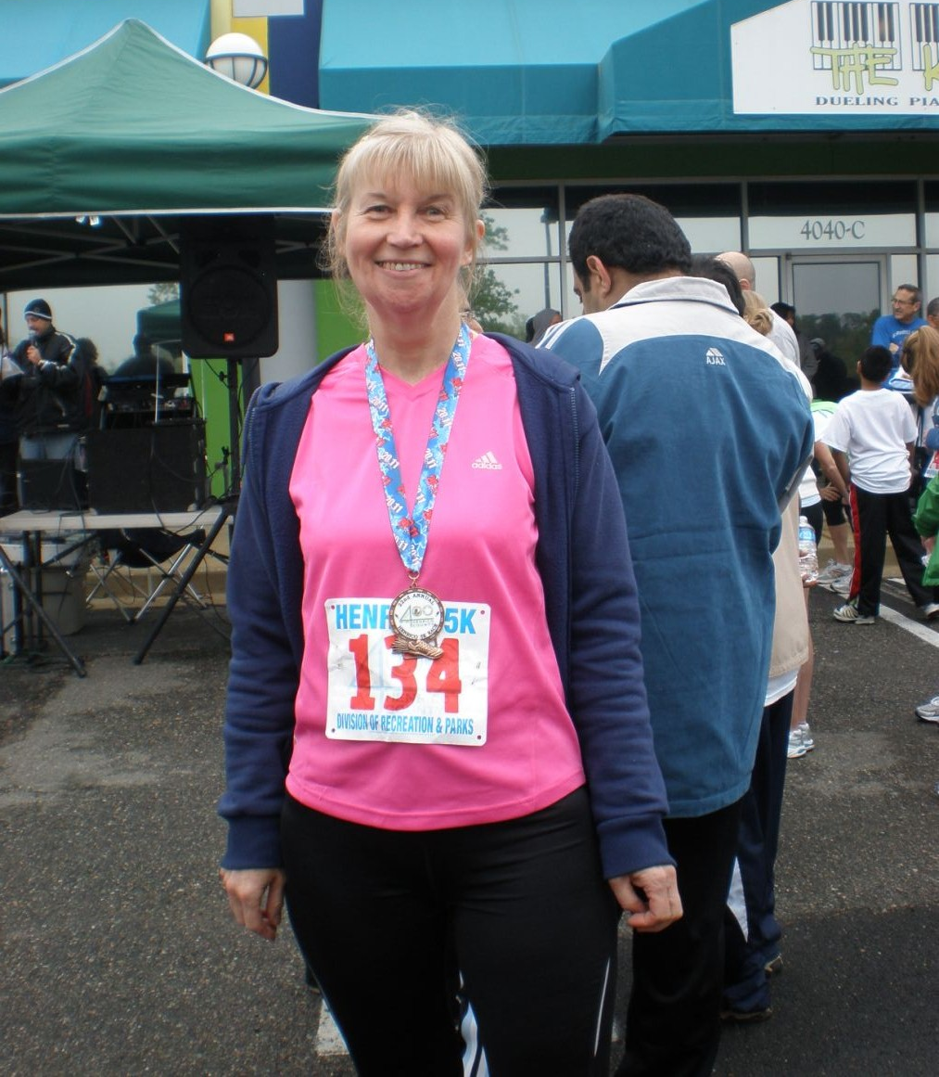

Jane Tomlinson 10K

Sandra: Yesterday I ran the Jane Tomlinson 10k and was hoping to do better than last year when I ran just under 53 minutes. Prior to the race was a little concerned as I had been for a gentle run on Wednesday after having done the Champagne League race the day before; after 3 miles I felt a twinge in my right calf so sensibly walked home. I think that Spout Hill the day before had put a bit of a strain on it to say the least!
Anyway I set off and felt okay but then the pain in my calf came back just before the 1 mile point. I started to panic a bit as I didn't want to cause myself an injury which would stop me training altogether and I didn't want to walk the 5 miles I still had to do. Anyway I managed to get round and my chip time was 53mins 31secs. I felt really disappointed as I really wanted to improve on last year’s time and I am now looking for another flat 10k to do.
So what did I learn from it - that I need to do more hill training to strengthen my calves but having said that the thought of running up Spout Hill does not fill me with enthusiasm!

Beverley 10K

Maria: What a fantastic experience!! Beverley 10K was my first proper race and I could not have picked a nicer route, yes it was tough but the scenery made up for the pain.
The joy I felt when I reached the finish line @ 1:02:26 (yes I still remember) was great and when I heard every one cheering I felt really proud and it almost brought me to tears. I have to say that joining West Hull Ladies was the best decision ever as the support and encouragement right from the beginning is brilliant not only from the really nice and lovely ladies I have met but also for the tips given from how to position your arms, how best to run down hill and so on and so on.

Ann: Here's my contribution - I've never written up a race before, well I've never ran a 10k before, so here goes ...
For the newer ladies - I'm new, too. I had my cruciate ligament reconstructed last summer, and the novelty of being able to run without pain now is still rather wonderful, as is being an actual runner, in a real running club. (Between you and me, I'm really proud to wear my WHL vest!). I was never good at PE at school, but the enthusiasm and support from the club has really encouraged me to just get out there and have a go.
So yes, the 10k - I told my physio of my plans, and when he asked me what time I thought I'd do, I said I'd be happy to do it in 70 min, and he reckoned on 65, so that became my goal.
I was so excited by the crowds (yes VLM and GNR ladies, I haven't seen nothing yet - but it seemed busy to me!), and I didn't even mind the threat of rain at the beginning. It was great to see the little ones in their fun run first - how many other sports get the children involved as much as running events?
A very slow start getting past the start line, but I had my timing chip, so that was fine. The cheering was great - I felt like a celebrity! Onto the Westwood, and the climb began. This was fine, too, because I'd had a little practice with Jo a few Sundays back, so I knew I'd manage it. The cows running alongside us were entertaining! Half way up the hill I spotted a colleague - a PE teacher, and then I passed her! I felt 10 feet tall, then. Top of the hill, a bit of a drink, and then met up with other WHL, which was nice. I tried to keep up when my PE teacher colleague overtook me, but couldn't quite manage it. Still, I was coping pretty well, and just enjoying my run.
Turning left to head back down through the Westwood was a good feeling - past half way now. The runners had thinned out now, and I was in my zone, keeping an eye on the time and thinking the sub 65 was going to happen.
I knew folk had said the last mile was the longest, but I hadn't reckoned on the band. Now I really did feel like a celebrity, because it was as if the band had waited for me to turn the corner before they struck up with the James Bond theme, and I was on the home straight. Ladies - the last bit was the best - cobbles, yes, but what a thrill, to be running with the streets lined, yes lined, with throngs (ok, too much) of supporters. I felt so special, and picked up the pace considerably.
I had no idea what the time was when I passed the finish line, because I was looking at the smiles of my partner and children waving me in. Job done, as Ruth would say. Off for my water and banana - I was ready for that, and then, yes - I got the T-shirt - my first ever!!
So it was a super day - and perhaps the best bit is that my partner Carol and my kids were really inspired. Carol's started a new fitness regime, and the children have insisted I sign them up for the Fun Run for my next 10k. I'd call that a result.
And my chip time - 59.38 - get in!!!

(Is now a good time to ask for your support for my next challenge? I'm doing the Great North Run in September - I've been inspired by the reports of other WHL. I'll be running for Mind, and I'd be really grateful for your support, however small. 1 in 4 people are likely to suffer mental distress every year, so their work is very important.
You can donate on www.justgiving.com/annholmes in anticipation - thanks ever so much!!)

Ruth: Becky told me just before the start of the race that she was intending to treat the race as a bit of a training run and to run at my pace. While I was flattered that she wanted my company (!) I was less sure she'd manage to keep to my pace. Maria also lined up with us - another person who I was sure could turn on a burst of speed when required. Anyway we set off with Becky picking off other runners one by one and Maria and I gamely sticking with her. Already I was wondering what had happened to Becky's intention to run at my pace!! As we toiled up the first hill Becky said chirpily how we'd manage this really easily because of all the hill training we'd been doing but I was unable to come up with a cheerful response (or even any response at all) because I was wheezing too much and sounded like a steam engine. I slogged on to the first water station with my breathing all to pot where Becky and Maria both grabbed their cups, drank and ran. I grabbed my cup and was unable to swallow so had to walk a bit to get myself sorted out. I waved Maria and Becky on with a mixture of relief to see them go and disappointment that I couldn't match them but fortunately for me Rachel was at the water station too and we paired up. The less said about our run to the next water station the better (the words 'flagging' and 'seriously' might best sum it up). At this water station I drank some water and chucked the rest of it over my head which was a strangely liberating experience and Rachel and I plodded on again. I found a lady to be our 'pacer' and we stuck behind her - I think she was about 70!! The run down the Westwood was good and the man at the top spraying us with water was a blessing. I found the music in Saturday Market really helpful and at the end when Rachel suggested a bit of a sprint I gave it a go and discovered to my horror that I could sprint - so obviously I hadn't been running to my full potential on the way round.
I was disappointed by my time - but I was not alone as everyone else seemed the same but - on the plus side - everything was really well organised and it was worth it for the tee-shirt - easily pleased - that's me!!

Racing and Running Events

2011 | Date | Time | Event | Distance | Fee | Notes
June | 19th | 11:00 | Leeds 10K Run for All | 10K | £9 | -
June | 19th | 10am + 2.30pm | York Race for Life | 10K + 5K | £14.99 | Online entry
June | 26th | 10:00 | Humber Bridge Half Marathon | Half Marathon (fun run also) | £20 | Online entry
June | 26th | 11am | Bridlington Race for Life | 5K | £14.99 | Online
July | 3rd | 11am | Cleethorpes Race for Life | 5K | £14.99 | Online entry
July | 3rd | 10:45am | Withernsea | 5 mile (3K fun run also) | £8 | Postal entries only
July | Friday 8th | 7:30pm | Walkington | 10K | £11 | Online entry
July | 17th | 11am | Hull Race for Life | 5K | £14.99 | Online entry
July | Wednesday 27th | 7pm | Laxton | 10K | £8 | Online entry
August | 7th | 10:30 | Idle Trail Race, Bradford | 10K | £8 | Online entry
August | 7th | 10am | Jim Dingwall, Elloughton | 10K | £10 | Online entry

** Dates/times are subject to change **
Keep checking the website for new races and updates: www.westhullladies.org.uk/races.htm Verity, Racing Officer

Please send in your race reports for the July newsletter. I know many people did the Humber Bridge 10K and I’m sure that the Humber Bridge half marathon will give some great reports too. Don’t worry if you haven’t written a report before, it’s great to hear them all, long or short!
NOTE: Club Vests must be worn at any races you enter
under the West Hull Ladies running club name.

Clubwear
PRICES:
Vest | £15.00 | All items are ordered on request and must  be paid for at time of ordering. To place an  order please get in touch via West  Hull Ladies e-mail and mark your emails  for the attention of Geri.
T- shirt | £16.50
Hoodie | £14.00
Jacket | £32
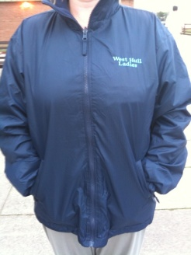
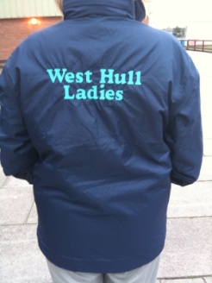
New Club Jacket available in three sizes: small, extra small, and junior (large fitting). If you would like to purchase one please send a cheque for £32 to Victoria Voase, Treasurer, and state on the back of your cheque your name and that the cheque is for a jacket.

Becca

Running Library

Email the club if you wish to borrow any of the books.
Book List:
- The Runner's Diet (Runners World), Madelyn H. Fernstrom
- Paula My Story So Far, Paula Radcliffe
- The Runner's Handbook, Bob Glover
- The Competitive Runner's Handbook, Bob Glover & Shelly Lynn Glover
- Marathon Running For Mortals, John Bingham
- Lore of Running,

Running Magazines: These are available to borrow by emailing the club website.
Mark your email for the attention of Becca.


